I International Meeting of Pharmaceutical Science
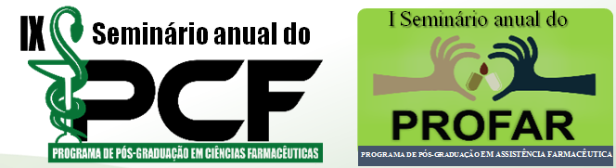

TITLE – SHOULD BE CLEAR AND OBJECTIVE, IN CAPITAL LETTERS

Authorª; First Co-author^{b}; Second Co-author^{c}; ...
ª Laboratory, State University of Maringá, Maringá, Paraná. e-mail:fulana@gmail.com
Key-words: Please, provide 3 keywords to identify your abstract.

The main text must contain 2500 characters at most.
Introduction:………………………………………………………………………….…………………………………………………………………………………………….………………………………………………………………………………………….……………………………………………………………………………………………….….Aim:……………………………………………………………………………………………………………….……………………………………………………………………………………………………………Methods:……………………………………….…………………………………………………………………………………………….………………………………………………………….…………………………………………………..……..Results:………………………….……………..……………………………………………………………………………………………………………….…………………………………………………………………………………………….…………………………………………………………………………………………….…………………………………………………………………………………………….………………………………………………………………………………Conclusion:……………………………………………………….…………………………………………..………………………………………………………………………………………………………………………………………………………………………………………….

Acknowledgments: financial support must be included.

References: At least 1 and maximum of 5.

(1) Bruce CR, Thrush AB, Mertz VA et al. Endurance training in obese humans improves glucose tolerance and mitochondrial fatty acid oxidation and alters muscle lipid content. Am J Physiol Endocrinol Metab. 2010;291:99–107.

